Ghv3 Operation Guide

Please make sure you read this manual before using !

(All of the features of our board are accessible even with using only one momentary button. )
1,If you order high end replica saber, the chassis is removable . Due to the GHv3 board doesn’t has short-circuit protection. Make sure to match the pins. One side is 6 pin ,another side is 5 pin. Short circuit caused by improper operation is not covered by warranty. | 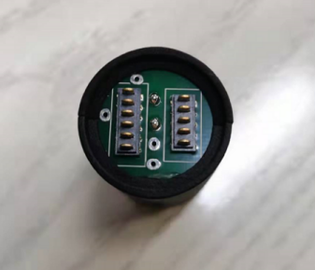
2,Make sure put the battery in right position after charging. Don't flip the positive and the negative. Normally you only charge the battery for 3-4 hours if battery run out. | 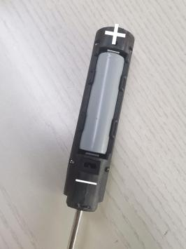
3.When charging, you need to take out the battery and put it into the charging compartment. Please pay attention to the positive and negative poles, otherwise the charging will not succeed | 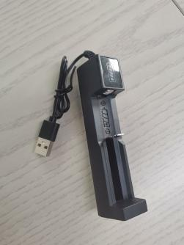

FUNCTION | TRIGGERING WITH ONE MOMENTARY SWITCH
Power On  Enter Effect Menu | Tap the button  Hold the button, then hold it again. Point the saber upwards while doing this.
∟ Change Blade Profile* | ∟ Slowly twist the saber
∟ Change On Top Effect* | ∟ Tap the button
∟ Save And Leave | Hold the button until the confirmation sound is played
Enter Accent Menu | Hold the button, then hold it again. Point the saber downwards while doing this.
∟ Change Standby Accent Profile* | ∟ Tap the button
∟ Enter Ignited Accent Submenu | ∟ Hold the button for 1 s
∟ Change Ignited Accent Profile* | ∟ Tap the button
∟ Save And Leave | Hold the button until the confirmation sound is played
Enter Color Change Menu | Hold the button, then tap it. Point the saber upwards while doing this.
∟ Cycle Through Preset Color Profiles | ∟ Slowly twist the saber
∟ Save And Leave | Hold the button
Enter Lockup Mode | Hold the button, release it and then twist the saber. Point the saber upwards while doing this.
∟ Leave Lockup Mode | Tap the button
Enter Drag Mode | Hold the button, release it and then twist the saber. Point the saber downwards while doing this.
∟ Leave Drag Mode | Tap the button
Enter Melt Mode | Hold the power button, release it and then perform a stab
∟ Leave Melt Mode | Tap the power button
Blaster Block | Tap the button
Force Push | Hold the button while swinging the saber
Activate Power Saving | Hold the power button while performing a stab
Deactivate Power Saving | Hold the power button while performing a stab
Power Off | Hold the power button until the saber shuts down
Enter Sound Font Menu | Hold the button before the blade is ignited, then release it. Point the saber upwards while doing this.
∟ Go To Next Sound Font* | ∟ Slowly twist the saber
∟ Jump 10 Sound Fonts Further* | ∟ Tap the button
∟ Save And Leave Sound Font  Menu | Hold the button
Menu

Show Battery Indicator | Hold the power button while performing a stab before the saber is ignited
∟ Calibrate Battery | ∟ When your battery is fully charged, perform a stab while battery level is displayed
Enter Volume Control | Hold the button before the blade is ignited, then release it. Point the saber downwards while doing this.
∟ Adjust Volume | ∟ Slowly twist the saber
∟ Save And Leave Volume Control | Tap the power button
Start Background Music | Hold the button while twisting the saber before the saber is ignited. Point the saber upwards while doing this.
∟ Skip Track | ∟ Quickly twist the saber
∟ Stop Background Music | Hold the button while twisting the saber before the saber is ignited
Enter Saber Editor | Hold the button while twisting the saber before the saber is ignited. Point the saber downwards while doing this.
∟ Select Editor Mode | ∟ Tap the button
∟ Color Profile

∟ Select Color Profile | ∟ Slowly twist the saber
∟ Edit Color | ∟ Slowly twist the saber
∟ Go To Next Saber State | ∟ Tap the button
∟ Revert Colors To Default | ∟ Perform a stab
∟ Save Color Profile | ∟ Hold the button
∟ Confirm Selection | ∟ Tap the button
∟ Save and Leave Editor Mode | ∟ Hold the button
∟ Pixel Number | ∟ Slowly twist the saber
∟ Edit Pixel Number

∟ Save and Leave Editor Mode | ∟ Hold the button
∟ Ignition Speed
∟ Select Sound Font | ∟ Slowly twist the saber
∟ Edit Ignition Speed | ∟ Slowly twist the saber
∟ Save Ignition Speed | ∟ Hold the button
∟ Confirm Selection | ∟ Tap the button
∟ Save and Leave Editor Mode | ∟ Hold the button
∟ Retraction Speed

∟ Select Sound Font | ∟ Slowly twist the saber
∟ Edit Retraction Speed | ∟ Slowly twist the saber
∟ Save Retraction Speed | ∟ Hold the button
∟ Confirm Selection | ∟ Tap the button
∟ Save and Leave Editor Mode | ∟ Hold the button
∟ Battle configuration

∟ Blaster Block Mode

∟ Button and Swinging | ∟ Slowly twist the saber clockwise
∟ Button | ∟ Slowly twist the saber counterclockwise
∟ Force Push Mode
∟ Button and Swinging | ∟ Slowly twist the saber clockwise
∟ Button | ∟ Slowly twist the saber counterclockwise
∟ Lockup Mode

∟ Button and Clashing | ∟ Slowly twist the saber clockwise
∟ Button | ∟ Slowly twist the saber counterclockwise
∟ Save and Leave Editor Mode | ∟ Hold the button
∟ Gesture Controls

∟ Stab Ignition

∟ Turn stab ignition on | ∟ Slowly twist the saber clockwise
∟ Turn stab ignition off | ∟ Slowly twist the saber counterclockwise
∟ Swing ignition

∟ Turn swing ignition on | ∟ Slowly twist the saber clockwise
∟ Turn swing ignition off | ∟ Slowly twist the saber counterclockwise
∟ Twist Ignition

∟ Turn twist ignition on | ∟ Slowly twist the saber clockwise
∟ Turn twist ignition off | ∟ Slowly twist the saber counterclockwise
∟ Twist Retraction

∟ Turn twist retraction on | ∟ Slowly twist the saber clockwise
∟ Turn twist retraction off | ∟ Slowly twist the saber counterclockwise
∟ Save and Leave Editor Mode | ∟ Hold the button
∟ Effect Font Slot

∟ Select effect font slot | ∟ Slowly twist the saber
∟ Save and Leave Editor Mode | ∟ Hold the button
∟ Save And Leave Saber Editor

∟ Confirm Selection | ∟ Hold the button
Wake Up From Deep Sleep | Tap the button
Reset | Hold the button for 10 s
* When changing the On Top Effect, Background Effect or Sound Font, you can go to the next one by pointing your saber upwards during selection or to the previous one by pointing your saber downwards.

Frequently Asked Questions
NO.1 Ask : There are no blaster and lockup effects in Neopixel setup for example. How can I fix that?
Answer: The most probable reason for this is that you forgot to activate the Neopixel light effects on your microSD card. Please follow the steps described in the section "Choosing Your Light Effects"

NO.2Ask: My blade is blinking white. How can I fix that?
Answer: The white blinking indicates that your microSD card is not inserted properly or some files or folders are missing on it.

NO.3Ask: There is no sound or stuttering sound. How can I fix that.
Answer: Please recharge your saber.

NO.4Ask: Some sound files are not played or some sound fonts are not recognized. How can I fix that?

Answer: Please check that your sound font folders and the sound file names are enumerated continuously and check the naming of the sound files.

NO.5Ask: The Seedling Module is connected to my computer, but even after 10 minutes it does not recognize the microSD card as mass storage device. How can I fix that?

Answer: Please check the device manager, look for an "unknown device", click on it with the right mouse button and uninstall the "unknown device". After that, you can try to reconnect the Seedling Module to your computer. Also make sure that you are using a computer withWindows 7 or Windows 10.

